ss

UMER KHURSHID

**DATABASE PROJECT**

(FEATURES, REQUIREMENTS, ER DIAGRAM, RDM ,SQL QUERIES )

# Project Title:

Online bank & Investment Site

**FEATURES**

# Summary:

Synthetix is a crypto backed synthetic asset platform that provides on chain exposure to real world currencies. The idea of this project would be to contribute to their organization and buy or sell assets through their platform. Keep track of the transaction history and make a user-friendly interface to search for news and updates regarding finance and the crypto market. There will be a login page where you can register yourself or login to your account if you already have one.

# Organization:

Synthetix Network Token (SNT)

# Users:

Swing Traders to keep a record of their investments and stay up to date with the latest market trends

# Features:

* You can register yourself or login to your account
* Record of all the transactions made will be shown
* You can add and delete data
* Stored data can also be edited
* Search engine is available to search for market related news
* You can purchase or sell properties or investments through the application if you have credit
* Logout

**REQUIREMENTS**

**REQUIREMENTS:**

The **Online Bank and Investment Project** is an attempt to make trading and investing easier for people who don’t have neither time nor the knowledge of the market but are interested in making investments. Through this website any person who has credit can register themselves. **Admin** is the main authority who can do addition, deletion and modification if required.

The site will be under the supervision of the admin and they will have their relevant information like Name, Address, Phone# and Gmail. For the investor to register first he needs to create an account which will require his Name, Gmail_ID, First_Name, Last_Name, Address, Phone#, and Password. After than he will be given a unique ID from which he can verify himself every time he is logging in into his account using his Gmail_ID and Password.

After logging into their account, the user will be shown the current credit they have in their account and different options to deposit and withdraw money if they want. There will be different pages in the website like; transaction history with total profit or total loss, Market data with fluctuating prices every time you refresh the page, Trending news to learn about the best places to put your money in and a search bar to search for market related news.

In the Market data section, there will be different options for the user like Real Estate, Stocks, Forex, NFT’s and Crypto. With each market the opportunity of profit and the risk of loss will be displayed on top.

User can then log out of their account and login whenever they want. Their account will not be accessed by anyone else.

**ER MODEL**

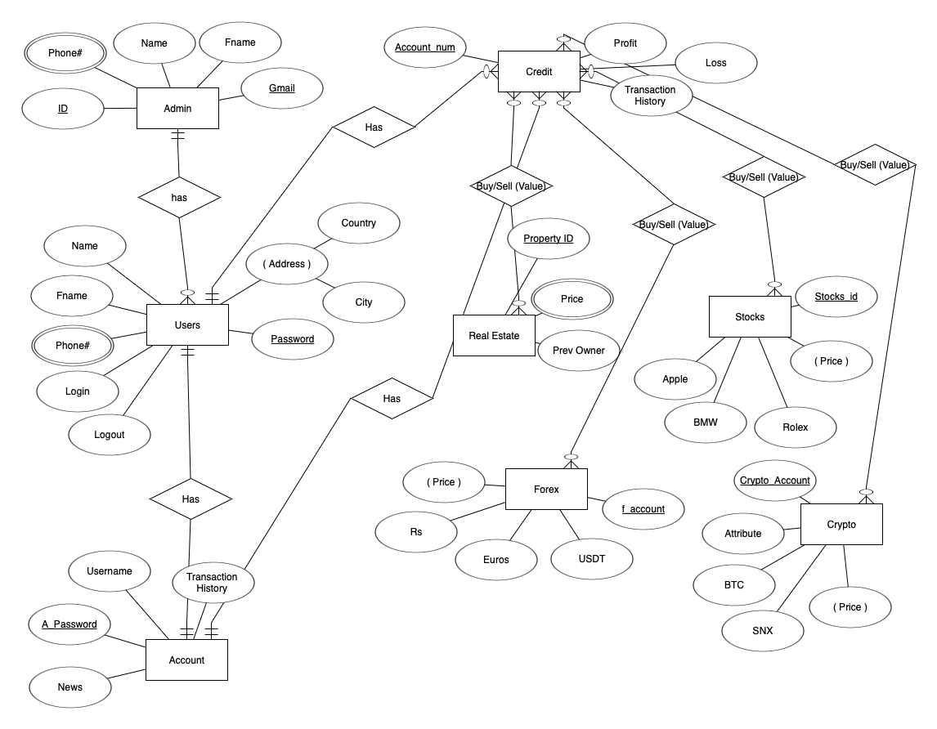

**RDM**

* Admin (id, name, Fname, gmail)
* Phone # (number, …id…)
* Users (password, name, Fname, login, logout, …id…)
* Address (city, country, …password…)
* Phone # (number, …password…)
* Account (a_password, username, news, transaction_history, …password…)
* Credit (account_name, profit, loss, …password…, transaction_history, …a_password…)
* Real estate (property_id, prev_owner)
* Price (amount, …property_id)
* Buy Sell (Value) (…account_number…, …property_id…)
* Forex (Euros, USDT, Rs, amount, f_account)
* Buy Sell (…f_account…, …account_number…)
* Stocks (apple, BMW, Rolex, account, stock_id)
* Buy Sell (…account_number…, …stock_id…)
* Crypto (BTC, SNX, amount, crypro_account)
* Buy Sell (…crypro_account…, …account_number…)

**SQL QUERIES**

**Create database PROJECT;**

**Use PROJECT;**

**CREATE TABLE admin** ( id int(50) PRIMARY KEY NOT NULL, name varchar(255), Fname varchar(255), gmail varchar(255));

//multivalue attribute phone#//

**CREATE TABLE phone#** ( number int(50) NOT NULL, PRIMARY KEY (id) REFERENCES admin(id));

**CREATE TABLE users** (password varchar(255) PRIMARY KEY NOT NULL, name varchar(255), login varchar(255), logout varchar(255),

FOREIGN KEY (id) REFERENCES admin(id));

**CREATE TABLE address** (city varchar(255), country varchar(255), FOREIGN KEY (password) REFERENCES users(password));

//multivalue attribute phone#2//

**CREATE TABLE phone#2** (number int(50), FOREIGN KEY (password) REFERENCES users(password));

**CREATE TABLE Account** (a_password varchar(50) PRIMARY KEY, username varchar(255), transaction_history varchar(255), FOREIGN KEY (password) REFERENCES users(password));

**CREATE TABLE credit** (a_number int(50) PRIMARY KEY, profit int(50), loss int (50) , FOREIGN KEY (a_password) REFERENCES Account(a_password));

**CREATE TABLE Real_estate** (property_id int(50) PRIMARY KEY, pre_owner varchar(255));

//multivalue attribute price//

**CREATE TABLE price** (amount int(50), FOREIGN KEY (property_id) REFERENCES Real_estate(property_id));

//many to many//

**CREATE TABLE Buy_Sell** (a_number int(50) PRIMARY KEY, FOREIGN KEY (property_id) REFERENCES Real_estate(property_id));

**CREATE TABLE Forex** (f_account varchar(50) PRIMARY KEY, USD int(50) , Rs int (50), Euros int (50));

//many to many//

**CREATE TABLE Buy_Sell** (f_account varchar(50) FOREIGN KEY , FOREIGN KEY (a_number) REFERENCES credit(a_number));

**CREATE TABLE Stocks**( stock_id int(50) PRIMARY KEY, rolex varchar(255) , apple varchar(255), BMW varchar(255));

//many to many//

**CREATE TABLE Buy_Sell**(FOREIGN KEY (a_number) REFERENCES credit(a_number), FOREIGN KEY (stock_id) REFERENCES Stocks(stock_id));

**CREATE TABLE Crypto**( cypto_account int(50) PRIMARY KEY, BTC int(50), SNX int(50) , amount int(50));

//many to many//

**CREATE TABLE Buy_Sell** (FOREIGN KEY (crypto_account) REFERENCES cryto(crypto_account), FOREIGN KEY (a_number) REFERENCES credit(a_number));

**\*\*\*\*\*\*\*\*\*\*\*\*\*\*\*\*\*\*\*\*\*\*\*\*\*\*\*\* THE END! \*\*\*\*\*\*\*\*\*\*\*\*\*\*\*\*\*\*\*\*\*\*\*\*\*\*\*\*\***